College of Computing

Computer Science Department

CS3141 Team Software Project

Spring 2022

**Project Knievel**

Section: _R02_______________________

Team #: _11________________________

|  |  |  |
| --- | --- | --- |
| Roll # | Name | Role |
| 10 | Ben Fosdick | Scrum Master |
| 9 | Logan Eerdmans | Developer |
| 11 | Preston Foster | Developer |
| 12 | Kelby Gingerich | Developer |
| 14 | Ymailda Hernandez | Developer |

Instructor:

Serein AL-Ratrout

# **Abstract**

(***Abstract*** *is one-paragraph summarizes your project, describes the content and scope of the project objective, methodology, findings, and conclusion. So, you need to write one-paragraph that gives an abstract idea about the entire project, the aim of the project, the process model you used, the tools, what you have done, the results, and your conclusion. If you think the project is worth extending to a Final Year Project (FYP) by you or other students or can be adopted and extended by industry/market, then mention that here and add it also as future work.)*

Example of abstract

In this project a student registration web application for university students and staff was developed, the aim of this application is to provide a simple set-up of programs for student enrolment, improve efficiencies and eliminate unnecessary paperwork. The system mainly has two modules: students and staffs. Students can create account then sign in/out, add, update, delete, and modify their data and schedule. Staff can also create account and then sign in, add, update, delete, and modify their data. Waterfall process model followed during project development and the implementation was realized by use of object-oriented PHP, HTML, MYSQL and Dreamweaver technologies.

It has been found that the final system was simple and user friendly with easy user interface, hence the end-users do not need to undergo extensive training or require any special skills. It was also secure, and reliable.

____________________________________________________________________________

____________________________________________________________________________

____________________________________________________________________________

____________________________________________________________________________

____________________________________________________________________________

____________________________________________________________________________

# **Table of Contents**

# **Table of Figures**

Chapter 1

Specification

# **1.1 Introduction**

Project Knievel is a mobile application that generates a trick or series of tricks for scooter, bike, and skateboard riders. It will have a collection of tricks that the user can add tricks to that are not already in the collection, remove tricks, and edit the name and/or description of the tricks. This application can be used by riders at parks or in street locations to generate a trick in order to help the rider improve their skillset and learn tricks that are out of their current trick vocabulary.

# **1.2 Problem Statement**

Riders often have a difficult time coming up with tricks to learn. This primarily occurs when they do not have people to ride with who are better than them or know different tricks. Other times, riders get stuck in a rut of only doing a few tricks that they already know and do not learn new tricks in part because they don’t know what to try. Alternatively, when riding in groups that have significantly different skill levels, it can be difficult to enjoy games like “S.C.O.O.T.” because the person(s) that are better, choose tricks that are well out of the less experienced player’s skill level.

# **1.3 Aim and Objectives**

The aim of this project is to develop a cross platform mobile application to help Scooter, Skateboard, and BMX riders expand their trick vocabulary, learn about skatepark features, and create an attainable yet competitive riding experience with fellow riders.   
**Objectives:**

* To allow riders to generate tricks to perform…
* To display information about skatepark features…
* To educate riders on what tricks can be performed and how to perform them…
* To measure trick vocabulary expanding progress…
* To encourage a healthy, competitive riding experience with friends…

# **1.4 Stakeholders** The primary audience are Scooter riders, Skateboarders, and BMX riders. As well as the development team and managers.

# **1.5 Methodology**

We used the Agile methodology called Scrum which follows the process below:

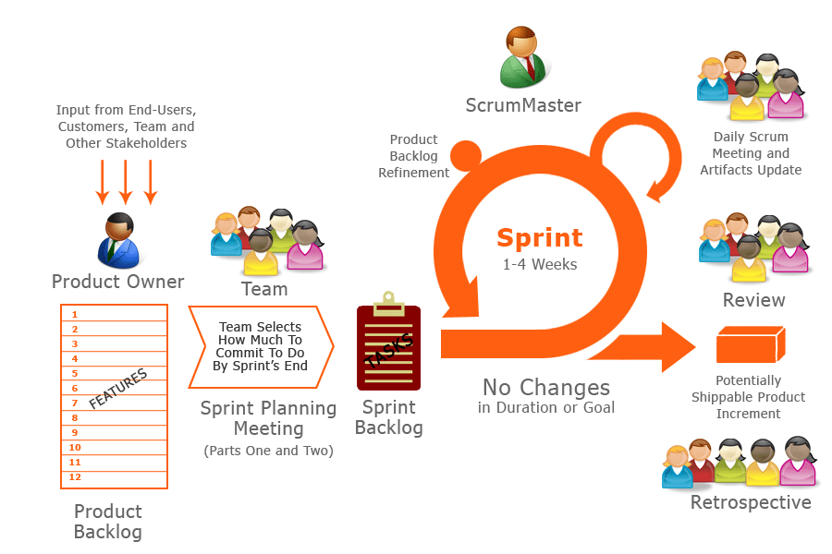

Fig 1. Diagram of Scrum process

**Product Backlog:** A list of prioritised feature requirements containing all the user stories for the product that the product owner assigns and drafts.

**Sprint Planning Meeting:** A planning meeting at the beginning of a sprint to revise the product backlog (Team effort) to select condensed goals of the user stories to put in the sprint backlog.

**Sprint Backlog:** The features that the team and product owner have agreed upon to implement during a given sprint.

**Sprint Daily Meetings:** Daily update meetings that should last no more than a few minutes to keep the team on track. It includes three main questions for each developer and asked by the scrum master: What have you gotten done since the last meeting? What am I working on next? What are my blocker/obstacles (if any)?

**Sprint:** This is an allocated time of 1-4 weeks of work and development of the tasks in the product backlog. Each sprint ends when the predetermined sprint timebox ends.

**Retrospective:** The team reflects on the work that was completed in the last sprint and what can/should be improved on for the next sprint. Solutions can be presented to be executed in the next sprint. There are two primary questions asked: What went well in the last sprint? What could be improved in how we worked in the last sprint?

**Three roles:**

**Product owner:** The person who defines the feature requirements for the product.

**Scrum master:** The developer who is responsible for facilitating the scrum process.

**Team:** The developers that are allocated full-time to a sprint.

# **1.6 Tools**

We will use Git and Github for version control and collaboration and Google Flutter SDK to develop the cross platform application. Dart is the primary programming language we will use.

# **1.7 High-Level Business Requirements**

## **Functional Requirements**

* The user should be able to indicate whether they ride Scooter, Skateboard, or BMX
* The user should be able to generate a random trick to perform on what they ride
* The user should be able to add, delete, and edit tricks names and descriptions on the list of tricks
* The user should be able to check whether they know a trick or not on the trick list
* The user should be able to check whether only tricks they know are generated
* The user should be able to press a link to YouTube on how to perform a given trick
* The user should be able to see a stream of images or a GIF of the trick being performed
* The user should be able to see pictures and descriptions of different skatepark features. (Down rail, quarter pipe, mini ramp).
* The user should be able to select a rideable feature(s) and only have tricks for that/those feature(s) generated(Ie. “doing a rail sesh.” or “mini ramp sesh.” or to check only features that are present at a given skatepark).
* The user should be able to see their progress as they learn more tricks and move up in the difficulty levels.
* The trick list should be organised/displayed into different difficulty levels.

## **Non-functional requirements**

* Portability: Must work on mobile devices. Must not exceed a reasonable amount of space for a mobile application.
* Compatibility: Must work cross platform on IOS and Android OS.
* Performance: Trick generation should take less than 0.25 seconds. Pages must load within 2 seconds.
* Core functions should be available offline
* Scalability
* Usability: Users should be able to use the application with minimal training

# **1.8 Product backlog**

|  |  |  |  |  |
| --- | --- | --- | --- | --- |
| **Priority** | **User Story** | **Tasks** | **Estimated Effort** | **Sprint** |
| **1** | **As a Rider, I want to select what vehicle I ride, so that I can generate tricks that can be done on my vehicle.** | **Design and implement the interface** | **2 H** | **1** |
| **Organise the trick lists for the different vehicles** | **1 H** |
| **1** | **As a Rider, I want to generate random tricks depending on what I ride.** | **Design and implement interface** | **2 H** | **1** |
| **Implement a trick list** | **2 H** |
| **Implement trick generation from the list** | **1 H** |
| **2** | **As a Rider, I want to add, delete, and edit trick names and descriptions on the trick list.** | **Design and implement interface to display tricks** | **2H** | **2** |
| **Implement add functionality** | **1H** |
| **Implement delete functionality** | **1H** |
| **Implement edit functionality** | **1H** |
| **2** | **As a Rider, I want to check if I know/understand a trick on the trick list.** | **Design and implement interface to display a trick description** | **2H** | **2** |
| **2** | **As a Rider, I want to only generate tricks that I know/understand.** | **Implement a toggle associated with each trick that indicates whether it will be generated** | **2H** | **2** |
| **2** | **As a Rider, I want to be able to watch a YouTube video on how to perform a trick on the trick list.** | **Design and implement an interface to display a link to a matching video.** | **1H** | **3** |
| **2** | **As a Rider, I want to visualize the performance of a trick via a set of images or GIF.** | **Design and implement an interface to display the unique images of each trick** | **2H** | **3** |
| **2** | **As a rider, I want to input that I have learned or completed a trick and am ready to get generated a new one** | **Design and implement functionality to mark tricks as complete and generate a new one.** | **2H** | **3** |
| **3** | **As a Rider, I want to see pictures and descriptions of different features that a skatepark provides and only generate tricks based on what features the park provides.** | **Design and implement an interface to display info about a given skatepark.** | **4H** | **4** |
| **Implement functionality to make notes about a certain skatepark.** | **2h** |
| **Implement functionality to display a helpful chart about a given skatepark’s features.** | **4h** |
| **Design and implement an interface to generate tricks based on skate park features.** | **3H** |
|
|
| **3** | **As a Rider, I want to record my progress and increase the difficulty level of performing tricks and only generate tricks based on difficulty level.** | **Design and implement an interface to record user progress.** | **2H** | **4** |
| **Implement a difficulty based trick generation system.** |
|

Chapter 2

Analysis and Design

# **2.1 Use Case Diagram** A diagram was constructed to help visualize as well as organize the basic standard setup used for the application. This was made using PlantUML, a free, online tool made for the design creation of use case diagrams. The diagram also shows fundamental connections between the user and related actions to help represent the structured flow that the stakeholders can expect to follow.

Fig 2. Use Case Diagram of Project Knievel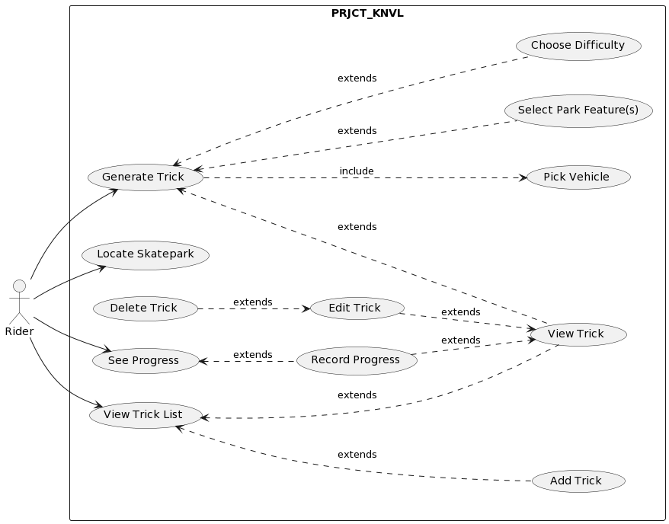

Chapter 3

Implementation

The following [report](http://people.uncw.edu/simmondsd/documents/450_Implementation%20and%20Testing%20Report.pdf) is a good example that you can follow for implementation please refer to pages 25 - 30, and here is another [example](http://api.uofk.edu:8080/api/core/bitstreams/13308397-e07c-47ef-83e5-3bbb2e9f0a81/content) for your reference.

Chapter 4

## Validation

**For Chapter 4 (Validation)**: here you need to write about the process of checking that your software system meets specifications and requirements so that it fulfils its intended purpose, and to confirm or to prove the accuracy of your project.

Write about your testing and validation; **level of testing** you had, unit testing, integration testing, validation testing and acceptance testing.   Did you have **manual or automated** testing or both? specify the part(s) that have automated testing and part(s) that have manual testing, and **What is your oracle?**

**Write the** **test cases** for valid and invalid **input** (please see Week3 Automated Testing/ slide 11),

then confirm that no errors in the code and the application is able to operate in required condition (OS, web browsers) and you have created the code correctly.

For validation and acceptance testing write who tested your system? MTU students? computer science student? other department students? your group only? other college students? public users? How many students/users? How many times? could they use it easily or did they make mistakes?

Chapter 5

## Limitations and Future Work

**For Chapter 5**

Limitations: address everything that the project left,  if some project backlog items/ features/ requirements have not been implemented then mention them in this part with an explanation/justification why you couldn't implement them (Time constraints the time was not enough, some developers were unavailable, because of COVID19, or  tool limitation ....etc.). Many students tend to feel that presenting the limits of their work makes work weaker. on the contrary, approaching this section shows maturity for the academic universe, and writing about them actually strengthens your work by identifying any problems before reviewers/readers find them.

Future work : if the limitations can be addressed in the future then add this in here in future work, moreover, if you believe this project can be extendable (add more features/ more parts) that the project is worth extending to a Final Year Project (FYP) by you or other students or can be adopted and extended by industry as a product so you can give directions for that in future work.

Chapter 6

Conclusion

**For  Chapter 6 (Conclusion),**: write what you have concluded.

Examples:

I solved many problems in the project…

This application/project/system was applied to improve the learning process.

The results of this project showed that system significantly facilitated the students' learning process.

The system is useless, acceptable, usable, beneficial or maybe enjoyable and why do you believe that.

References

(Include any references to external documents or materials (for example, tutorials the team will be using, literature , web references or links to documentation of third-party tools you will use) here.

The references should be properly numbered and correctly used in the text.

The Reference section should be in the following fashion:

# References

[ ] Serein Alratrout," introduction to scrum" ,lecture notes, access date: September/2022

Journal, Magazine/ Newspaper Article

|  |  |
| --- | --- |
| [1] | Author, "Title," *Journal name,* p. pages, year.  Book |
| [2] | Author, Book Title, publisher, year.  Internet Web page: |
| [3] | Author, "Name of the Web Page," [Online]. Available: URL. [Accessed Date]. |